**E Voting System For UPR Senate**

|  |  |
| --- | --- |
| Rehan Khan  2020-B-SE-256 | Arslan Khalid  2020-B-SE-263 |



Supervised by

Mr Faheem Yaqoob

A Final Year Project Proposal Report is

Submitted in Partial Fulfilment of the

Requirements for the Degree of

Bachelor of Science in [ Software Engineering]

**Department of Computer Science&Information Technology**

**University of Poonch Rawalakot**

**2024**

Contents

1.Introduction: 1

2. Objectives: 1

3. Problem Description: 1

4. Proposed Solution(Solution Scenerio)…………………………………………………………2

5. Methdology: 2

6. Project Scope: 2

7. Brief Feasibility Study: 2

8. Solution Application Areas: 3

9. Functional Requirements: 3

10. Non functional REquirements: 4

11. Tools/Technology: 4

12. Expertise of the Team: 5

13.Milestones: 6

References: 6

**1.Introduction**

An E-voting system for UPR senate is a technology-driven platform that enables the casting and counting of votes electronically. This system aims to streamline the electoral process, making it more efficient, secure, and accessible.

One of the primary advantages of e-voting is its potential to increase voter participation by making voting more convenient and accessible, especially for those who may face difficulties reaching polling stations, such as overseas citizens, or those living in remote areas. Additionally, e-voting systems can significantly reduce the time required for vote counting and result tabulation, ensuring quicker and more accurate election outcomes.

**2.Objectives**

This project aims to fulfill the target of vote authenticity, fair and fast voting.The primary purpose of the E-Voting system for the UPR Senate is to replace the traditional voting system with a digital one. This new system aims to ensure the integrity and security of the voting process, increase voter participation, and streamline the overall procedure.

**3.Problem Description**

The university administration is seeking to develop a secure, reliable and user-friendly electronic voting system for the senate elections which replaces the traditional paper based voting system which often lacks authenticity and creates trust issues among the stakeholders. Moreover ,a voter can be out of region or does not get proper notification about the elections.

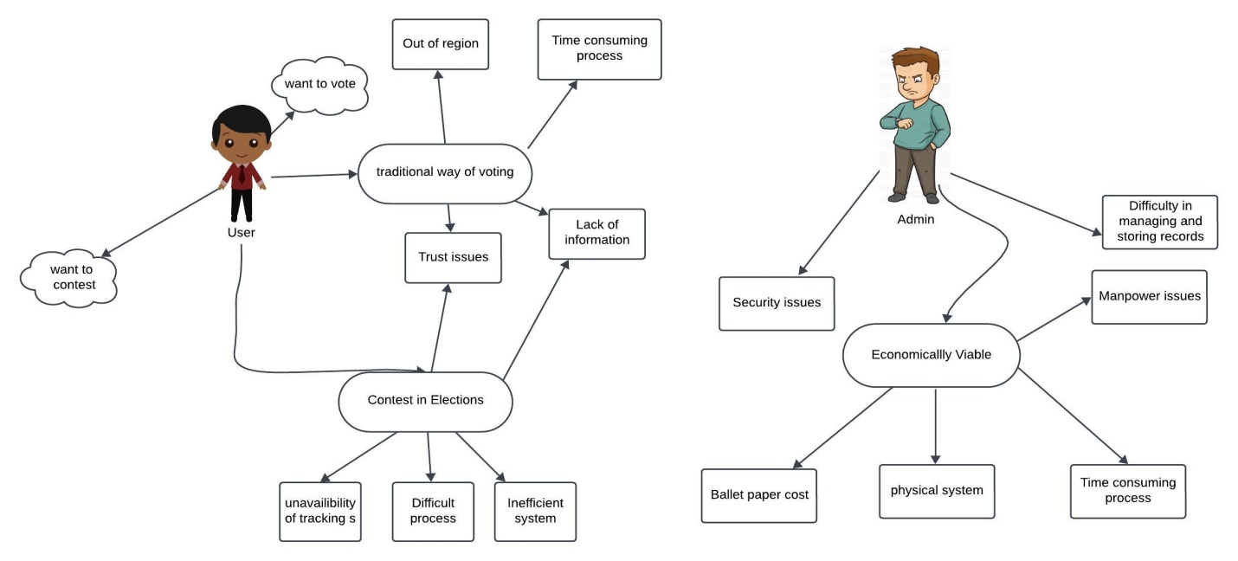

Fig. 1: Problem Scenario

**4.Proposed Solution(Solution Scenerio)**

The E-voting system replaces traditional system by providing safe ,reliable and anonymous system for voting.The voters can cast vote from anywhere using their unique id and recieve proper notification whenever the elections are held.

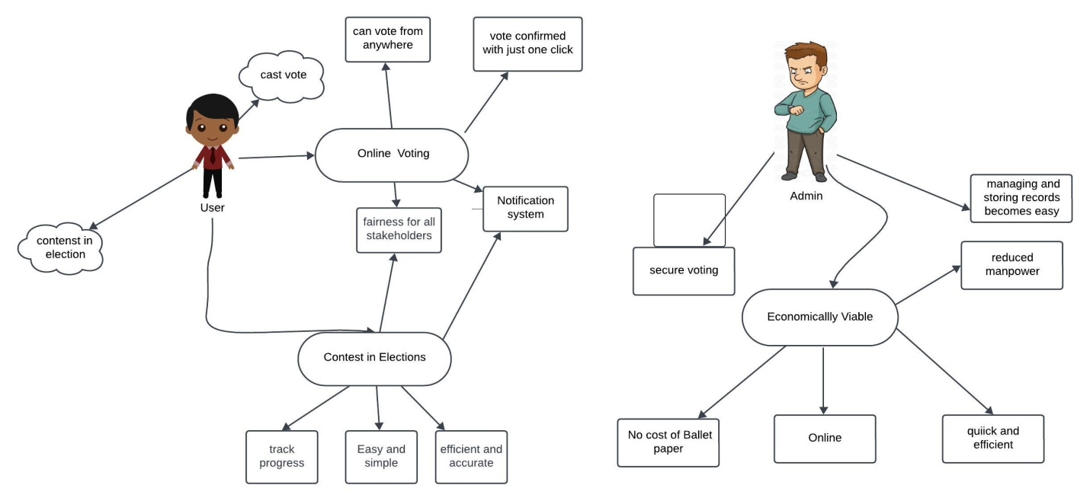

Fig. 2: Problem Solution Scenario

**5. Methodology**

To develop the E-voting system, we will follow a structured approach, ensuring thorough analysis, robust design, efficient development, rigorous testing, and secure deployment.

First, we will conduct a detailed requirements analysis to gather all functional and non-functional requirements from stakeholders. Next, we will create system architecture diagrams, user interface designs, and database schemas during the system design phase.

For development, we will use HTML, CSS, JavaScript, and Bootstrap for a responsive and user-friendly frontend, utilizing Visual Studio Code as our IDE. The backend will be developed using PHP, MySQL, and Ajax to manage server-side logic and database interactions. Security will be prioritized with multi-factor authentication (MFA) and encryption.

Finally, we will deploy the system on a secure server, performing final testing to ensure all functionalities work as expected. Post-deployment, we will provide ongoing maintenance and support to address issues, maintain security, and keep the system updated.

**6. Project Scope**

The scope of this project includes the analysis, design, implementation, and testing of an e-voting system. This system will be accessible to all eligible voters associated with the UPR Senate. The system will provide functionalities such as voter registration, secure authentication, vote casting, and result tallying.

**7. Brief Feasibility Study**

The project is viable across technical, operational, economic, legal, and timeline dimensions. Technically, the system can be developed using widely available technologies like HTML, CSS, JavaScript, Bootstrap, PHP, MySQL, and Ajax, ensuring robust security measures such as encryption and multi-factor authentication. Operationally, user training and support will facilitate ease of use, while maintenance protocols will ensure ongoing reliability. Economically, the initial investment in hardware and software development is offset by long-term savings from reduced paper and infrastructure costs, and potential funding from university budgets or grants is feasible. Legally and ethically, the system will comply with election laws and protect voter privacy and data. The projected timeline of six months from planning to deployment, with clearly defined milestones, supports a structured and achievable implementation process.

**8. Solution Application Areas**

This project will have a value in university as it can be integrated with LMS , whenever the university will conduct such elections the university management can rely on this project.

**9. Functional Requirements:**

**The functional requirements for admin are**

Registration and authentication

login

Add candidates

Remove candidates

Reject candidates

Document verification

Request additional documents if needed.

Symbol allocation

Notification system (Send notification to voter , send notification to candidates, document submission notification to candidates, polling, results)

Announcing Result

Logout

**The functional requirements for candidates are**

Registration and authentication

Login

Profile management

Document submission(Update ,Resubmit )

Document verification status (Rejected/Accepted/Pending)

View symbol

Report issues

Logout

**The functional requirements for voter are**

Register

Login

Profile management

Ballot access and voting

Vote confirmation

See results

Logout

**10.Non Functional Requirements:**

#### Security

* **Authentication**: Implement multi-factor authentication (MFA).
* **Access Control**: Restrict administrative functions to authorized personnel.

#### Performance

* **Scalability**: Handle a large number of concurrent users during peak times.
* **Response Time**: Ensure response time is less than 5 seconds for key actions.
* **Throughput**: Support at least 300 transactions per minute during peak usage.

#### Usability

* **User Interface**: Intuitive and user-friendly across devices (desktops, tablets, smartphones).

**11. Tools and technology**

* **11.1. Hardware**
* **Processor**:

Minimum: core i3

Recommended: N/A:

Minimum: 2 GB

Recommended: 4 GB or higher

* **Storage**:

Minimum: 1 GB available disk space

Recommended: SSD for faster performance

* **Mobile Devices**:

Android Smartphone (required)

iOS Device (optional)

* **Graphics**:

N/A

* **11.2. Software**
* **Operating Systems**:

Android OS (64-bit) version X.X or later.

* **Integrated Development Environment (IDE):** Visual Studio Code
* **Git**
* **Programming Languages**:

Php,javascript,html,css

* **Database**:

SQLite or Realtime Database (optional)

**12. Expertise of the Team**

We are confident in our ability to successfully complete this project. Our recent coursework in web development, mobile app development, and database management has provided us with a strong foundation in the necessary technical skills. Additionally, both of us have practical experience from working in a software house, where we gained valuable knowledge about managing and executing real-time projects. This combination of academic and practical experience ensures that we are well-prepared to tackle this project effectively and meet the deadline. We possess all the skills needed to deliver a high-quality final product.

**13.Milestones**

Table 1: Tentative schedule of different milestones

|  |  |  |  |  |  |  |  |  |
| --- | --- | --- | --- | --- | --- | --- | --- | --- |
| Timeline | April | May | June | July | August | September | October | November |
| Literature review/ Proposal Defense | 22nd |  |  |  |  |  |  |  |
| Data Collection | From 23rd | To 20th |  |  |  |  |  |  |
| Software Implementation |  | From 25th | ---------- | ------- | ---------- | To 15th |  |  |
| Result Compilation and Final Report Writing |  |  |  |  |  | From 17th | --------- | To 19th |

**References**

### [1] Fullstack Vue: The Complete Guide to Vue.js by Hassan Djirdeh, Nate Murray, and Ari Lerner

### [2] Mike Owens, Grant Allen, ”The Definitive Guide to SQL lite” - 2ndEdition, September 2010.

### [3]   Kyle Simpson’s You Don’t Know JS

**Signatures:**

1. Dr. Anum Mushtaq _____________________________
2. Dr. Muhammad Kashif Khattak _____________________________
3. Dr. Shamaila Hayat _____________________________
4. Dr. Adnan Ahmad Rafiq _____________________________
5. Dr. Lubna Zafar _____________________________
6. Dr.Irfan Javed _____________________________
7. Ms. Anam Naseer _____________________________
8. Mr. FaheemYaqoob _____________________________
9. Mr. Imran Farooq _____________________________